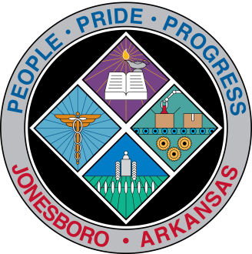
Communications Department
FOR IMMEDIATE RELEASE

Aug. 9, 2018

Contact: Bill Campbell
Director of Communications
870-933-7164 (o), 870-919-7042 (c)
bcampbell@jonesboro.org

Stormwater Board meets Wednesday

The Stormwater Management Board meets at 8:30 a.m. Wednesday, Aug. 15, in the first-floor conference room of the Municipal Center, 300 S. Church St.

###

