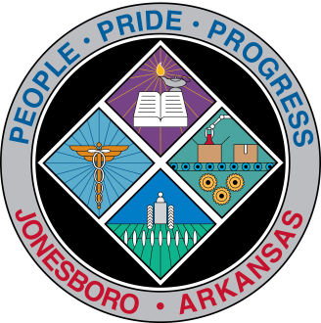
Communications Department
FOR IMMEDIATE RELEASE

Aug. 23, 2018

Contact: Bill Campbell
Director of Communications
870-933-7164 (o), 870-919-7042 (c)
bcampbell@jonesboro.org

City receives federal grant for new firefighter positions

The Jonesboro Fire Department will be able to add three new firefighters next year thanks in part to a federal grant received this week by the City of Jonesboro that will provide $291,587 over three years.

It will be used to add three firefighters for the city’s fleet of firetrucks, Chief Kevin Miller said.

“Three positions means another truck will constantly have a third firefighter,” Miller said. “This gets us one step closer to our long-range goal of having three firefighters on every truck.”

Mayor Harold Perrin said the grant could not be better timed. JFD had not received such a grant from the Federal Emergency Management Agency since 2004.

“I am extremely pleased to receive this grant from FEMA,” Perrin said. “It’s always good to add positions for public safety. We will always be vigilant when it comes to safety.”

The Staffing for Adequate Fire and Emergency Response grant will have to be approved by City Council. It reimburses the City for 75 percent of the new employees’ pay in their first two years, and 35 percent in the third. The City has six months to make the hires, and Miller said each new firefighter will require six months to a year of training.

Perrin praised the City’s Community Development Director Tiffny Calloway and Miller for winning the grant, and offered thanks for a support letter from U.S. Congressman Rick Crawford.

###

