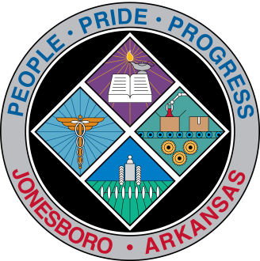
Communications Department
FOR IMMEDIATE RELEASE
Aug. 24, 2018

Contact: Bill Campbell
Director of Communications
870-933-7164 (o), 870-919-7042 (c)
bcampbell@jonesboro.org

Corridor committee meets Thursday

The next meeting of the A-State to Downtown Corridor Committee will be 1:30 p.m. Thursday, Aug. 30, in City Council chambers, 300 S. Church St.

###

