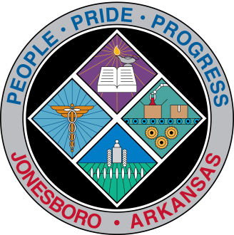
Communications Department
FOR IMMEDIATE RELEASE

July 16, 2018

Contact: Bill Campbell
Director of Communications
870-933-7164 (o), 870-919-7042 (c)
bcampbell@jonesboro.org

Parks objectives meeting set for Wednesday

A public meeting to identify potential outdoor park and recreation needs and priorities for 2019 will be held at 5:30 p.m. Wednesday, July 18, in the first-floor conference room at the Municipal Center, 300 S. Church St., Jonesboro.

City officials will submit recommendations to the Arkansas Department of Parks and Tourism for a matching grant application. Ethnic minorities, persons with special needs, those over age 55, and special interest groups are especially encouraged to attend and participate.

Those unable to attend the meeting can call 870.933.4604. Written comments may be emailed to dkapales@jonesboro.org or tcalloway@jonesboro.org. Written letters should be mailed to the City of Jonesboro, Grants and Community Development Department, Attn. Tiffny Calloway, P.O. Box 1845, Jonesboro, AR 72403-1845 or 300 S. Church St., Ste. 402F, Jonesboro, AR 72401.

###

