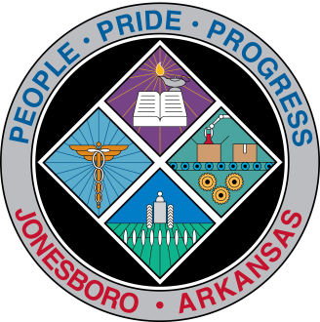
Communications Department
FOR IMMEDIATE RELEASE

July 20, 2018

Contact: Bill Campbell
Director of Communications
870-933-7164 (o), 870-919-7042 (c)
bcampbell@jonesboro.org

MAPC to meet Tuesday

A Metropolitan Area Planning Commission meeting will be held at 3 p.m. Tuesday, July 24, in Council Chambers, 300 S. Church St., to consider pending agenda Items.
A meeting agenda is available on the City Clerk’s Legistar website: www.jonesboro.org or at http://jonesboro.legistar.com/Calendar.aspx.
Call the Jonesboro Planning Department at 870-932-0406 if you have questions. There will be no Monday pre-meeting.

###

