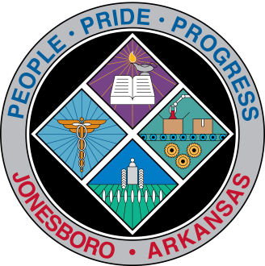
Communications Department
FOR IMMEDIATE RELEASE

July 23, 2018

Contact: Bill Campbell
Director of Communications
870-933-7164 (o), 870-919-7042 (c)
bcampbell@jonesboro.org

Animal Services offices closed part of Tuesday

City of Jonesboro Animal Control offices at 6119 E. Highland Drive will be closed for part of Tuesday, July 24, while its HVAC unit is replaced.

The work will begin at 8 a.m. and is expected to last roughly six hours. Calls to Animal Control should be directed to 870-935-5552 during this time, as Animal Control officials will be working out of the City’s E-911 Center. That number is to the service’s non-emergency line.

Normal service is expected to return at approximately 2 p.m.

###

